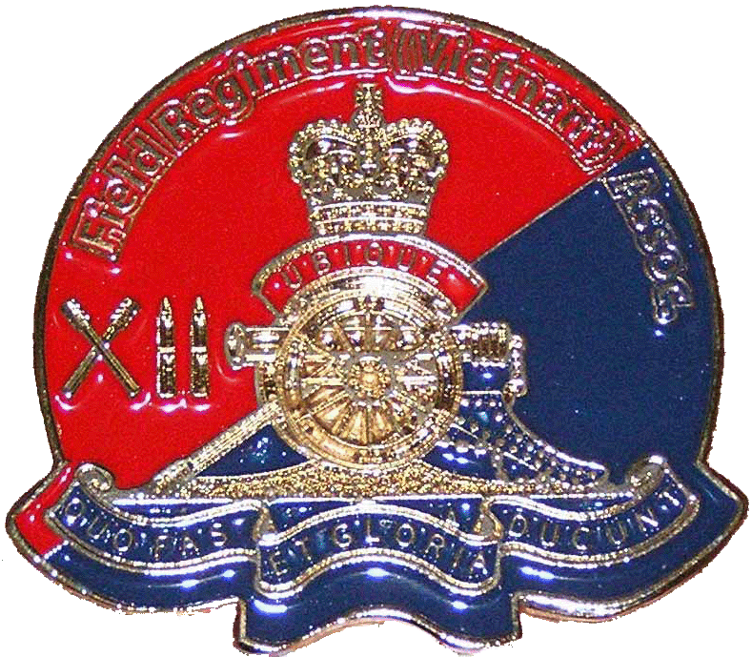
President:
Mr. Rob (Cossie) Costello
13 Pinnacle Close
BOLWARRA HEIGHTS NSW 2320
Phone: (02) 4930 3359
Mobile: 0409 432 346
Email: cossie0102@bigpond.com

Vice President:
Mr. Neil Mangels
Email: nma77081@bigpond.net.au
Website: http://12fieldregiment.com
Secretary:
Mrs. Elizabeth Mangels
P.O. Box 87 5th November 2007
CARDIFF NSW 2285

Treasurer:
Mr. Laurie Bird
Email: birds_12@optusnet.com.au
P.O. Box 87
CARDIFF.N.S.W. 2285

12 FIELD REGIMENT (VIETNAM) ASSOCIATION
(A Branch of the Royal Australian Artillery Association NSW Inc)

SUMMER NEWSLETTER

Good Morning All,

Since our Spring Newsletter the grass has not been able to grow under our feet as we have been busier than a Gun number on six rounds fire for effect on charge 4 with half of a Gun crew.

A couple of the executive had a few weeks off on holidays and came back refreshed, however they sure did have a backlog of mail to respond to on their return. Sadly I contributed to their backlog and by the time I had finished they were ready for another holiday.

I do hope that those on the Internet have had a look at our Website by now, it is looking better every week. Remember we want your contributions as well, to make it a great success. All you have to do is contact me or the Webmaster and we will get the details on the site, if suitable. Please help in this task as the main contributors have been the Webmaster and myself. It is essential that we get a good balanced view from all involved to make it the success it deserves.

I have no need to remind you all that our Association is for the benefit of all units and Sub Units of the Regiment and there is no problems at all in OUR Association placing advertisements, or notifications of reunions in both the Newsletters and Website. All you have to do is contact us. We are here for all of the Regiment and that includes all individual Battery and sub unit functions. All Battery Associations please keep this in mind!!!!

The Latest News.

On the 9th of November a couple of the executive are doing a return trip to Vietnam. The trip will cover such sites as Coral, Balmoral, Long Tan, Nui Dat, The Horseshoe and other sites. It is indeed sad that I never got the relevant info until a day before the closing date of the tour. It is a trip organized for Ex 1R.A.R Diggers and we had to make a rushed decision as to whether we should, could or afford to go or not. You have my assurance that I really couldn’t afford to go but I considered it imperative that I make the effort, as a young lady from the Uni of Queensland is doing a documentary on the Battle of Coral for release on or near the date of the 40th Anniversary. Due to the fact that there was little or no Artillery involvement in the tour we considered it essential to go to put an Artillery point of view across. I have spoken to the producer and sent her DVD’s, she is very excited with the material that I have sent her. She also has committed herself to cover the Battle from every angle.
I appeal that members hold email correspondence to the executive from the 9th of November to the 24th of November, the date of our return. However the Vice President and Secretary will be here to hold the Fort, but I would like them to have a little rest before the chaos of the New Year.
Page 1 of 6 … PTO

Sick List.

Sadly John Gainsford has passed away. We reported in the last newsletter that he was very ill. He was a good man of the Regiment. “Rest in Peace, John.”
To those who knew him well, pass on condolences to his family please. John Bird is recovering well and is in good spirits. Well done John!
In September I received news that 102 Batteries own Geoff Knox is ill from our old Battery Captain, Don Tait. Don was distressed to say the least; I can assure you that the news distressed me as well as many others in the Battery. I as well as many others have spoken to Geoff and his determination is nothing less than we would expect from a man from our proud Regiment. Geoff would love to hear from members of the Regiment and I do assure you that he will only talk to you in positive terms as only a man from our Regiment can do. Geoff we all love, and are thinking of you, I have no need to say keep your head up as you already have it in that position. Good on you Matey!!! You have our full support.

Geoff’s details are, Gunner Geoff Knox. 22 Glenbrook Close, Frankston South. Ph: 03 59711119
Email; knoxs@iinet.net.au.
Please contact Geoff, he would love to hear from you!!!!!!

Renewals Overdue Now!!!!
I remind all members:
If you do not renew your membership in the next six weeks you will receive no more newsletters and will be deleted from our mailing list. There are still around 56 people who have not renewed their yearly fees out of a membership of 249. This is a sad state of affairs.

We were formed in May of 2006 and now have the membership described above. If you 56 people fall out, our membership will be reduced by a quarter. We have planning in place for the Anniversary of 12 Field Regiments first tour of Vietnam to be carried out in February next year at a cost to your Association far more than your yearly membership thus far, all are invited to attend. In 2010 it will be the second tours turn and equally all will be invited to attend. The cost of the 2008 Reunion to you of $70.00 is a third of what it will cost your Association to carry it out through the good management of your executive in securing high interest bank accounts, memorabilia sales and benefit days to beef up our bank account.

All these actions have been carried out by four members of your executive team who have worked hard to get us to where we are now. Please do not let the Regiment down by slackness or forgetfulness in not renewing your membership. You have all been given 3 extra months for renewal to line up with the R.A.A.A. N.S.W. end of year 31/08/2007 (inclusive was June’06, July’06 and Aug.’06). PLEASE RENEW NOW. Should you feel like it, you could donate an extra $5.00 dollars to the Association for your extra three months membership. I point out that this is not obligatory at all.

I do advise that if you are a yearly subscriber to change it to perennial membership and this action will save you from having to remember every year to renew. I will enclose a renewal form at the end of this Newsletter.

The people on email that have not paid have been given their reminders electronically; the members on snail mail have also been sent reminders via the last newsletter, and now this one.

You must remember that we are amongst the lowest costing Vietnam Veterans Associations in Australia and we wish to keep it this way with your help. You were a part of our Regiment and at present, a part of the Association. Please keep it that way with your renewal, post haste, if you have not already done so!!!!!!! I also remind any of the above who are now on the internet to let us know of your address so we can forward mail to you via email.. And any others who are on it PLEASE notify us of any change of address.

A meeting with a Bombardier.

Our executive is meeting with, a Bombardier of 102 Field Battery in November to determine guidelines and objectives for a hardship fund to be established by him for the members of our Association. Your Association will top this fund up on a yearly basis to keep it in the black and ready to help those of the Regiment in hardship. This initiative alone reinforces my directive above to renew your membership to benefit this fund and your fellow Veterans that may be in need of help. There will be criteria set with this fund however, and it will be divulged in the autumn news letter, as well as the
opening balance of the fund.

Page 2 of 6 … PTO

Our Financials.

As you will all see later in the Treasurers report our financial position is more than sound at this present time. What can I say about a Treasurer that started his term with a balance of $3000.00 before the first mail outs? And now has a balance as is
stated in the financials. He has been like the rock of Gibraltar to our Association. He has handled everything with ease inclusive of the memorabilia, with no complaints ever and has often been a great settler for an often angry President.

Laurie was asked by me to help out on the committee on our inception last year, the day after I asked him to be our Treasurer, he agreed with trepidation, how glad I am that he did. The proof is in the Puddin. Just have a look what has been achieved in 18 months. Well done Laurie!!!!!!!!!!! I do remind you all however that a lot of these funds will go to the 40th Anniversary as well as the hardship funding, to supplement the Bombardiers’ funds. I also bring your attention to the fact that Laurie is coordinating the other Corps in the Coral celebrations, again after a request from me. Only today, 102 Batteries B.K. told me of the great job Laurie is doing in this area, I never had doubt that he would not handle it with ease. Laurie went underground after Vietnam but resurfaced a few years ago. Gee I am glad he did!!!!!!

Our Vice President and Secretary.

What can I say about Neil and Liz, they have done much more than initially asked of them, they have tried to source the missing members of the Regiment and have achieved great results. They have also worked very hard in areas that only relate to the Coral / Balmoral celebrations and are not relevant to our Association. They have done this with no complaint. Sadly, maybe one or maybe both of the above may resign next year at the A.G.M., I sure hope not, and if they do I would hope to see someone who is serious about it to pick up where they have left off. I point out though, that these jobs are not beer and skittles and are for people who wish to put in the hard yards. These two great people have done the hardest yards in getting the bulk of the Regiment together again after all these years. I do ask however, that should any one out there have a desire to stand for these positions and prepared to give their all, to stand for election at the next A.G.M. in February next year.

THANK YOU LIZ AND NEIL!!!!!!!! You are the greatest!!!!!!

To all members of the Regiment who were at Coral / Balmoral.

Sadly the D.V.A will not subsidise a lot of areas of the Coral Anniversary in 2008.

These areas are as follows. A welcome package for the Diggers on arrival at Canberra, and also two of the Bus trips from two of the venues, anyone who wishes to make a donation to any of these two essentials are most welcome. Please direct it to our Treasurer and he will lodge it into the Coral Artillery funds that are in no way related to our Association in any way. We as an Association are merely supporting it. The Co Chairman of the Coral / Balmoral committee. Colonel Don Tait, has genuine concerns that if buses are not provided for all venues, that some Diggers may risk their or another’s life by driving with a belly full of grog. We sure as hell don’t want anything like that happening on the Anniversary.

The Golf Day.

We are holding a Golf day in Newcastle to support the above shortcomings for the Coral Anniversary in March of next year; I point out to you again all that our Association WILL NOT put any money into it. The day will be supported by the following; The Vietnam Veterans of Newcastle, The Vietnam Veterans of Gosford, The Vietnam Veterans Legion of Maitland and the N.S.W. Branch of the Royal Artillery Association. All funding derived will be placed directly into the Coral / Balmoral Artillery account for the Anniversary. I do hope you can compete to make this a success. All enquires should be directed to Neil, Liz, Laurie or myself. I assure you all of great prizes and a great day for all involved. I would like to get the Burglars from down south around Victoria to compete but I do think they are scared to play in a real Golfing Tournament. More on this in the February newsletter.

We are also holding an Auction of artifacts at our reunion in February to raise funding for the monetary shortfall in May. The memorabilia for Auction will be donated my me, I assure all of their authenticity and do hope we can get the figures required to carry out the Coral Anniversary with the success it deserves. All the profits derived from this will also go to the Artillery Coral / Balmoral trust account and not into our funding. Should anyone else have items they want to surrender for the fundraiser, please contact the Committee?

I also received a phone call from one of the Regiment members the other day he said, Cossie, I was going through my Army trunk the other day and found a few things that may interest you if they don’t, I will throw them out. I said,” What are they mate?” He responded, “A belt buckle with the Vietnam star, a Knife and scabbard, shrapnel and splintex Darts. Your
Page 3 of 6 … PTO
Association is going to have them mounted and framed and it will be kept in perpetuity by your Association. Imagine the value of these items to a collector in a few years time. Bruce (My Dog) Morris, the Association thanks you.

At the end of this newsletter The Coral / Balmoral Veterans will be asked to fill in and return a questionnaire prepared by the
Coral Artillery Committee. THIS IS ESSENTIAL. Please do it directly after reading the rest of this correspondence and return immediately to our P.O. Box Number as outlined at the top of this letter. If you do not, it will effect funding from the D.V.A. which is very thin on the ground anyway. “Please Help”

Memorabilia

It appears that our memorabilia sales have reached a plateau and we need new ideas to continue funding for future years. About now I would say that most of you would be saying, “When is he going to stop asking for funding?” You all have my assurance that I won’t until the end of my term as President. We have to make sure that we have full funding at least, for the two tours of Vietnam reunions, and enough to carry on with thereafter. I make no apologies for that.
We must remember again, that our Association has the lowest rates of any other Vietnam Association. This has been achieved by our memorabilia sales and our golf day last year. I also point out that minimum charges are added to the cost of the end product. There will be also Memorabilia items in the future distinctive to a certain unit in the Regiment. My unit was 102 Field Battery and I will put forward what I have got for the sake of the Regiments funds. If anyone from any other Battery or sub unit has any other ideas and memorabilia they want to put up for sale please let me know. We should be able to copy it for all the other diggers in your unit. How pleased was I to see a member of 104 Field Battery ask where we got our distinctive badges from, as he was so impressed with them and wants to do the same for the members of his unit. We have only got to look at a member of the Regiment to thank for this, he has done a great job, and we do thank you BLUE for this great effort.

On ANZAC day this year Blue and I were close to each other in the March in Sydney. We had two young Scouts holding the 102 Battery Banner. It was wet, cold and windy with many hold ups. These poor kids had only shirt sleeves on and were very cold, they lasted to the very end of the march, without complaint. When I saw the great fortitude of these kids it restored my faith in the younger generation. Both Blue and I gave them a good tip at the end of the March . Sadly the others had gone before I could ask them to contribute. Nothing has changed!!!!!!!!

In this, and future issues you will continue to see the future memorabilia items that you may wish to purchase. It is up to you what you wish to do in this area. We will do our best to put the best products forward.

The present memorabilia can be seen within this Newsletter and on our Website http://12fieldregiment.com . I do point out that most of these items will be available at our reunions in February and May, however by purchasing now your executive will have a chance to be involved in the planned celebrations rather than sitting behind a table serving the people who were late in ordering. Please help!!!!!!!

The Fire for effect wines are overdue and should be released within the coming month. I do apologise for this, as a few factors had an effect on its delay. To those that have ordered, I would see you getting it in the next six weeks. Sorry about that fellas, I hope you weren’t thirsty!!!!! Both the wines and the port are displayed as well as the new items for sale. I remind you all, that you can pick these items up at the February or May reunion. If you want them now, courier charges will apply. All you need to do is contact our Treasurer and he will do as you choose, without delay.

The Pen holders on display on the next page are the new items for sale. The one on the left has a mini likeness of a M2 A2 Howitzer, with a cartridge case for the pen. Your name and Battery will be inscribed on the plate. The second has an Artillery badge, two cartridge cases for pen holders and your name and unit will also be inscribed on the plate. They are for sale at $45.00 each, plus postage.

Who could forget the welcome home parade in Sydney in 1987? It brought a lot of missing Vets out from the underground. In our memorabilia section in the next Newsletter we will be offering replica; good quality polo shirts far better than were offered at that great weekend, with an option of a photo and wording of yourself (your choice) in Vietnam, on the back. What a great item in a picture frame that would be for your family as a memento of you. I am guessing that it would cost around $70.00. I will let you know in the next Newsletter. Fortunately I have a good quality copy of the original shirt, but the new one would have far better quality in the graphics area, that was more than disappointing in the original as well as the poor quality of the T shirt. I assure you these shirts will be of top quality. We also will have on sale in our next News Letter Association monogrammed golf balls for all of our golfers., these balls are of top quality and will cost our members $3.50 each, 3 for $10.00 or 20 for $57.00 plus postage.

Prior to our Regimental reunion last year I had produced a twin D.V.D. of 102 and H.Q. Batteries first tour of Vietnam. Many of those were sold at the venue. The photos and the 60s music in these discs are just great, even if you are not a

Page 4 of 6 … PTO

member of these two Batteries, the music and photos will blow you away. You have to trust me on this!!!! These twin discs are now available through our Treasurer at the low price of $25.00 plus postage. I assure you that they will bring back many memories for all. They will be packaged to a standard that all Veterans of the Regiment would be proud of. As a bonus to this great deal you will also receive a copy of Ian Ryan’s D.V.D. Vietnam revisited, this is a combination of old 1968 photos and Movie footage of the present time in Vietnam inclusive of all the sites known to us, Coral, The Horseshoe, Nui Dat, Baria, Long Tan and S.A.S. Hill. Ian has done a great job in the detail of this film and is highly commended. I will guarantee that anyone who buys this package will not be disappointed. There is close to three hours of quality content in the three discs and I do mean quality, compared to a lot of things I have seen in the past. Order Now!!!!!

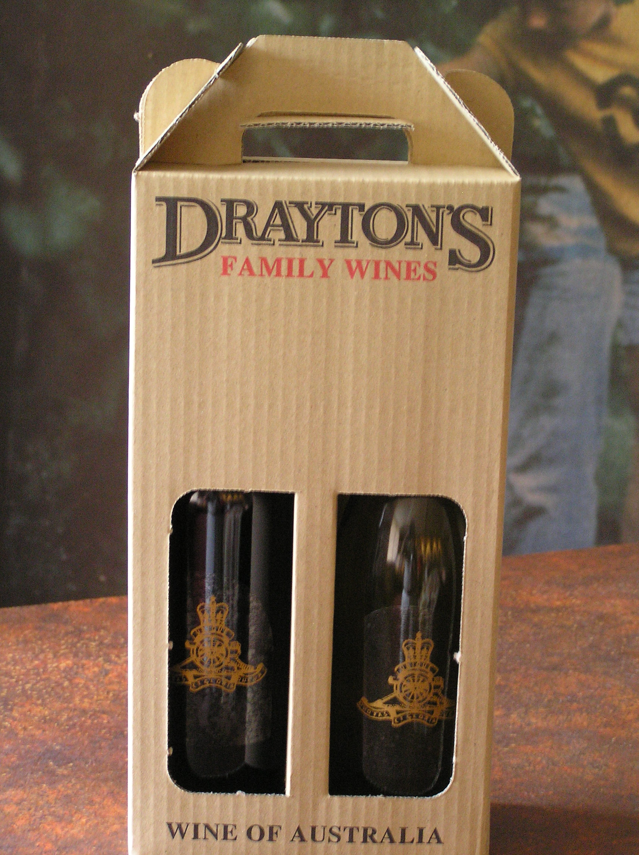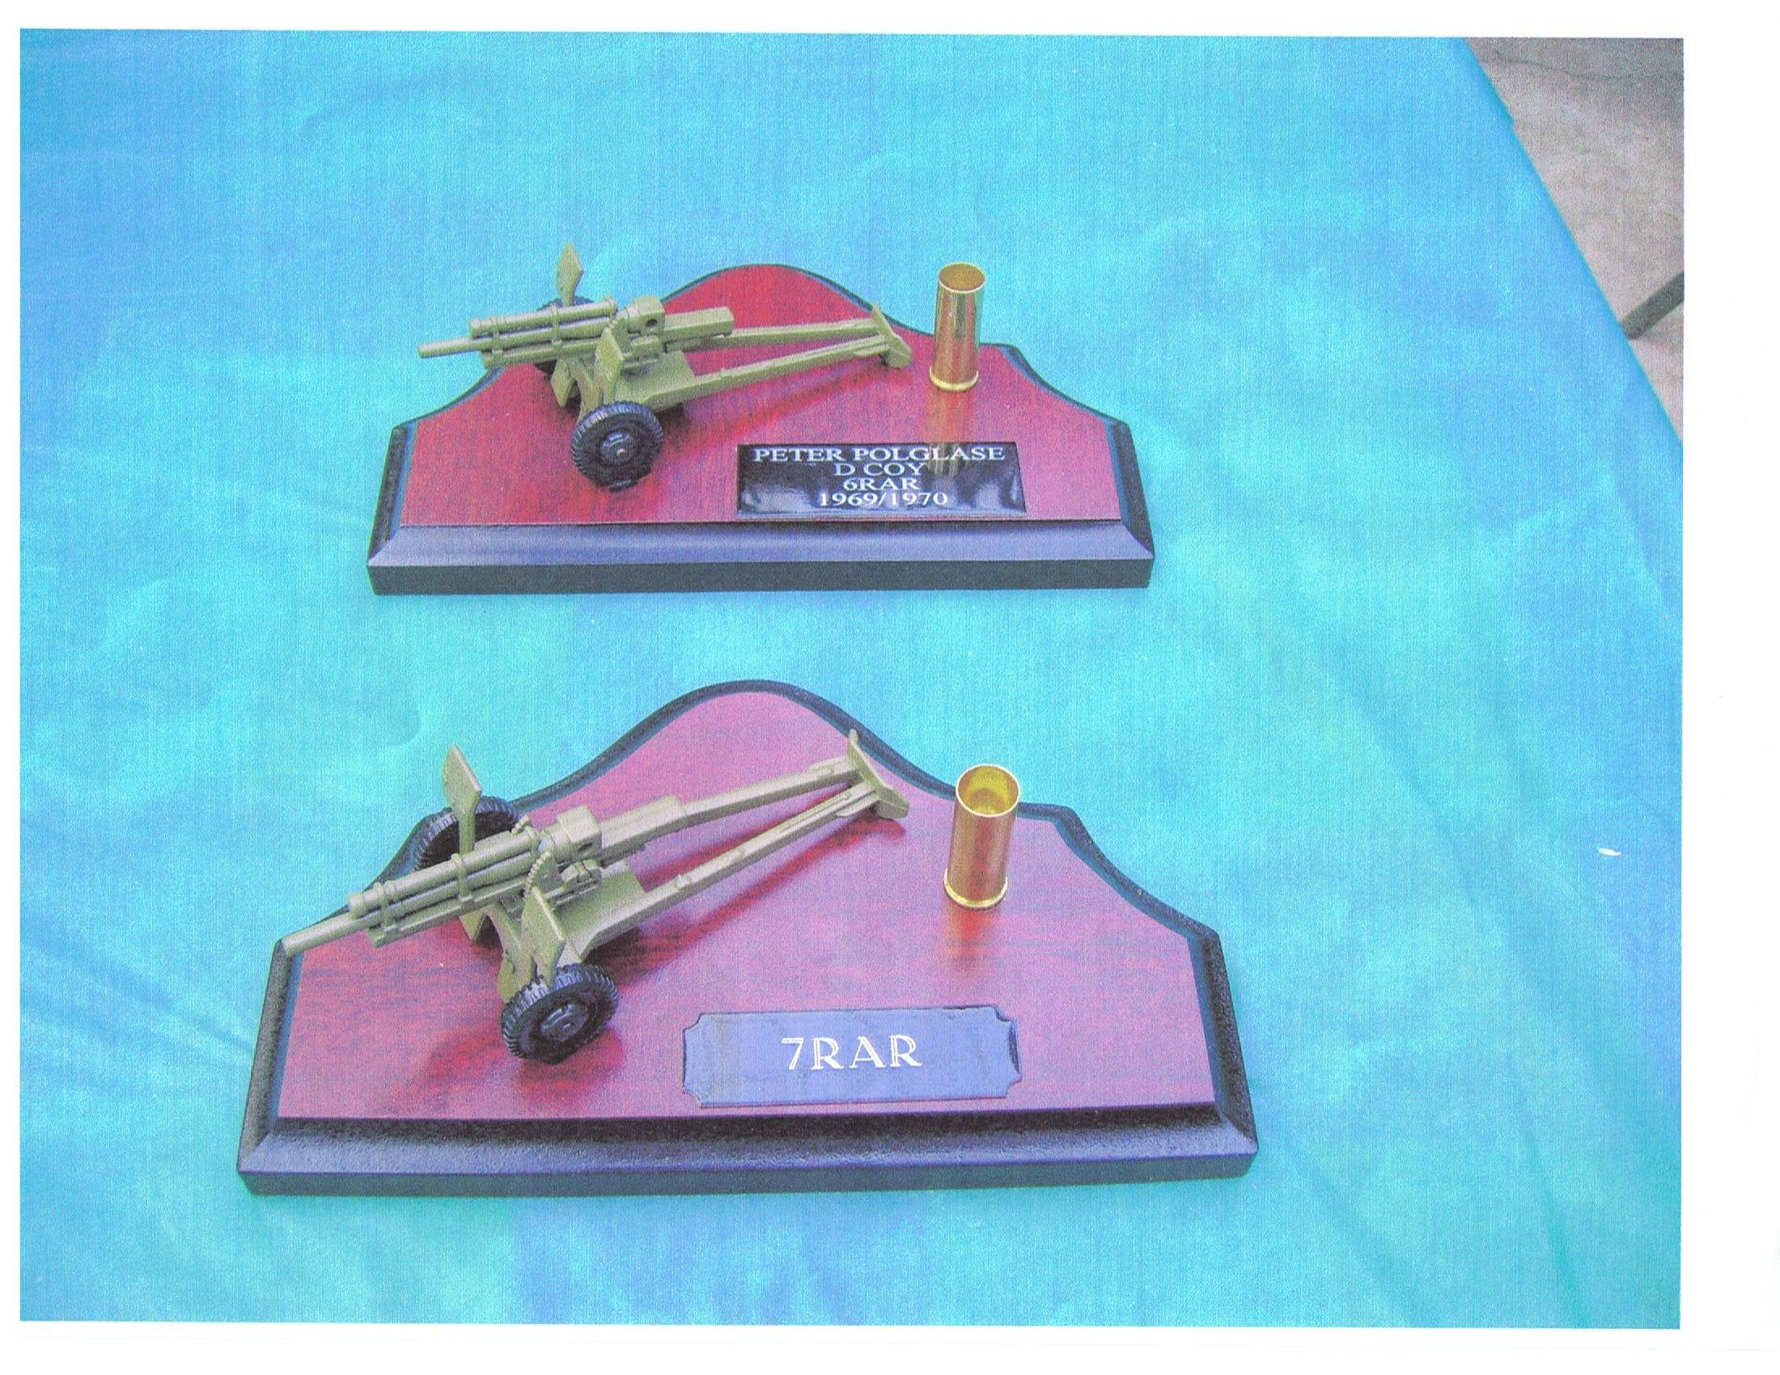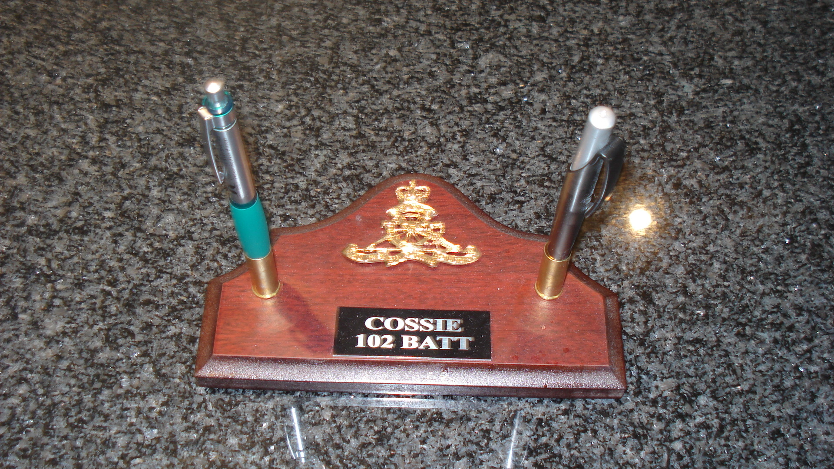

Missing Members and their Families.

Our campaign to find missing members has been a moderate success with a few more people found. Remember we want all members of the Regiments members and Families involved in our great Association. We are a National group catering for all members of the Regiment in both tours. Please help if you know of any ones details, this is most important.

The two Reunions next year.
At the present time we are asking for our members to state what they are doing for either or both of the functions next year. For the 12 Field members who haven’t notified the committee of their and their partner’s attendance in the February reunion at Bankstown Sports Club please notify us via the questionnaire at the end of this letter A.S.A.P. We must know the exact numbers, by the latest, early January. And also send your $20.00 deposit per person at least, or the whole amount of $70.00 each; this would make it easier for our committee on the day.

The Coral Celebrations:
As I stated earlier, this questionnaire is at the end of this news letter for all you blokes to fill in. If you have done it before but your plans have changed, please do it again as this is the official questionnaire as to what is going on and trying to find out what your intentions are.
Please do it now whilst it is fresh in your memory, and do not delay in sending it to our Secretary or Treasurer by email or post and also via our WEBSITE http://12fieldregiment.com. Hook on to it and have a look at what a member of the 8/12 Field Regiment has done for all of our Regiment. Thank you Graham, for a job more than well done. Graham has been an inspiration and has done more than asked for. In consideration that I talk to him briefly on occasions and he still comes up with the goods.

Graham has put an enormous effort into varying things to do with both functions next year in regards to programs and other things for the both of the events. What he has done you will all be proud of, and I do thank him for his kind and gracious efforts. But then again he WAS Artillery. He is an invited Guest to our function in February next year.

In conclusion, I remind you all that you were all a part of our Regiment and we must all pull together as we all once did to continue the pride we still have, and continue to have, as THE Regiment of Australian Artillery. So, if any members feel that they can contribute as part of the committee please put your hand up in February. But as I said before you must be committed 100%; if you do not have the commitment please do not put your hand up. There are a couple of blokes out there that I know who would do a good job for the Association and they know who they are, so come on fellas get up and have a go. The hard yards have been done. All you will have to do is maintain the work that some of the inaugural committee have achieved.
At the time of writing of this letter your executive committee has decided to ask for another Federal grant available to us for given the fact that we are a National non profit organization. The funding is available mainly for admin purposes. We have decided that it is essential for our Association to apply for it. It must be remembered that all postage, paper come from members subs. The computers, printers and other computer hardware and software costs are supplied by your committee at no cost. With this grant we will be able to disperse these costs to keep our equipment up to date and cost our membership very little. Please fill in and send the questionnaires attached today, do not leave it until tomorrow. This is most important for future planning. We want to be totally organized for the reunion and the Anniversary. PLEASE HELP!!!!! We are
only trying to help you.

Page 5 of 6 … PTO

Stop Press!!!!!!

After finalizing this edition of the Newsletter on the 15th of October, I was required to attend the A.G.M of the Royal Artillery Association N.S.W. Branch Inc, who is our parent body. You all know that we have been a Branch of the R.A.A.A almost since our inception, only last year. The advantages to our Association in being a Branch are enormous. Our capitation fees to the R.A.A.A are more than worth the money, as all of us are covered for any accident that may occur at any of our functions.

At the A.G.M. in general business a request was made by me to try and source funding from the Association for one of the bus trips for the Veterans at the Coral / Balmoral Anniversary. The funding required is $2500.00 dollars. With no fuss at all, the request was Moved, Seconded and passed unanimously in a period of no more than three minutes. We do thank the R.A.A.A. N.S.W. Branch for their kindness and generosity. Since being a volunteer Association rep to the R.A.A.A. I can only say that the Friendships that I have struck have been nothing short of amazing. And I do look forward to every meeting to hook up with new found friends that I have met since. It reminds me of the Friendships struck in the Army all those years ago.

To the President, the Committee and most of all the membership of the Royal Australian Artillery Association the Veterans of Coral / Balmoral, We thank you, and God bless you all.

A letter of appreciation has been written by me in appreciation from our Regiment to the R.A.A.A. (N.S.W.) branch for their great and wonderful donation

I also point out that we are negotiating with The Rydges Group of Hotels to help with the funding of the small group dinners at 6.30 P.M on the 13th of May. We have decided that the whole of the Regiment should be together on this occasion. So the plan is to have each detachment or group at their own tables that will be appropriately designated.

The Rydges Hotel at Eagle Hawk is located right next to the Holiday village where many people are staying. I would suggest to people who want higher class accommodation make enquiries to Rydges on pricing. I do point out however, that we have not negotiated accommodation prices and are still negotiating on the best deal for our Veterans in regard to the venue.
The ticket price for the small group dinners is $56.00 and that deal includes a three course dinner and drinks for the first two hours. I think that is an excellent deal in consideration of the quality comforts that this resort offers. It has recently undergone a 3.5 Million upgrade and certainly looks the goods.

We must all remember that if we are all close together here will be little problem with transport for the other functions as the buses can pick us up from the one location. We can also wander back to our room or cabin without the risk of an accident from Rydges. I do implore you all to think about it as we do not want anyone injuring themselves or others, though drunken driving on this, our Anniversary. PLEASE DO NOT DRIVE WHEN DRUNK!!!!!!!!!!!

Ubique, Cossie and our Committee.

Page 6 of 6

